Terraform Task

Task Description:

Launch Linux EC2 instances in two regions using a single Terraform file.

Techstacks needs to be used :
AWS EC2
Terraform
AWS CLI

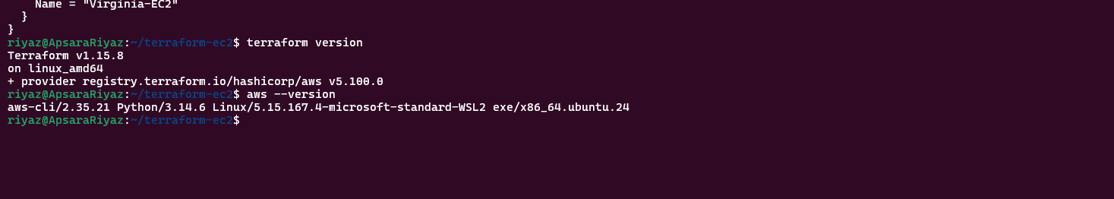
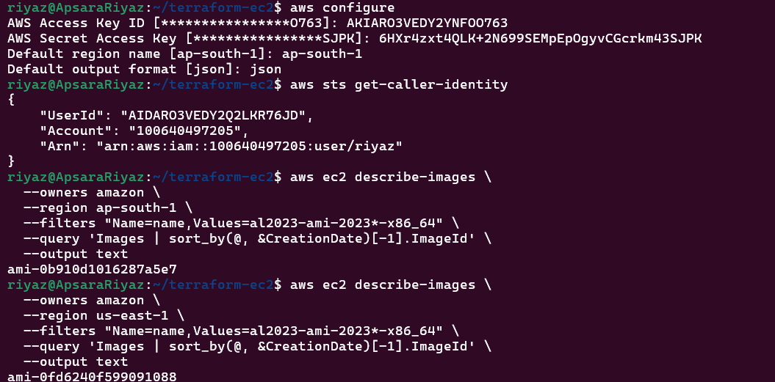
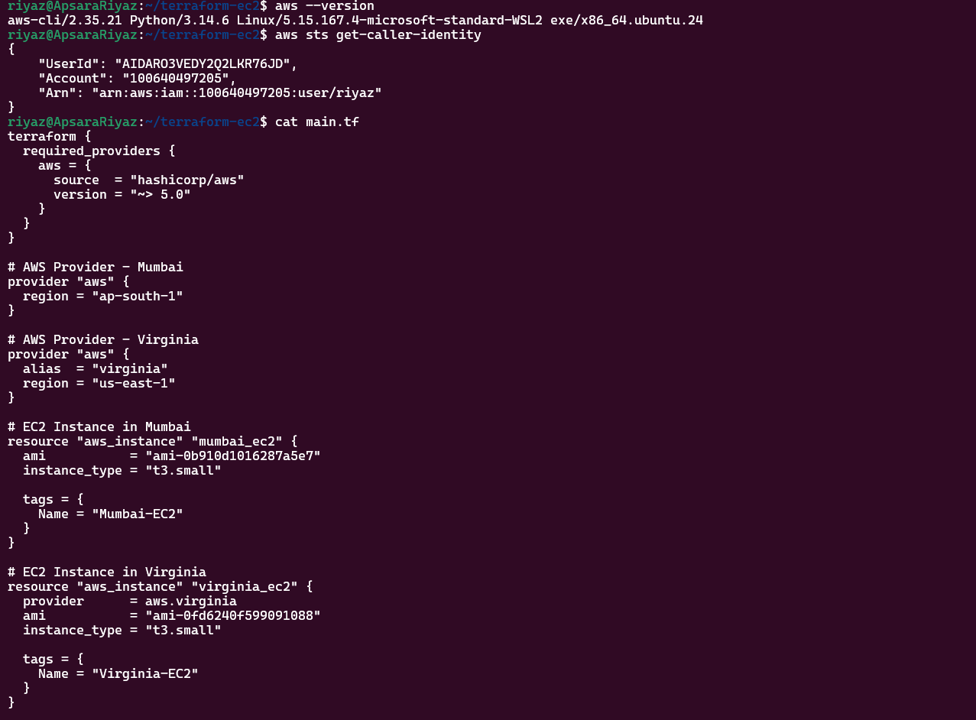

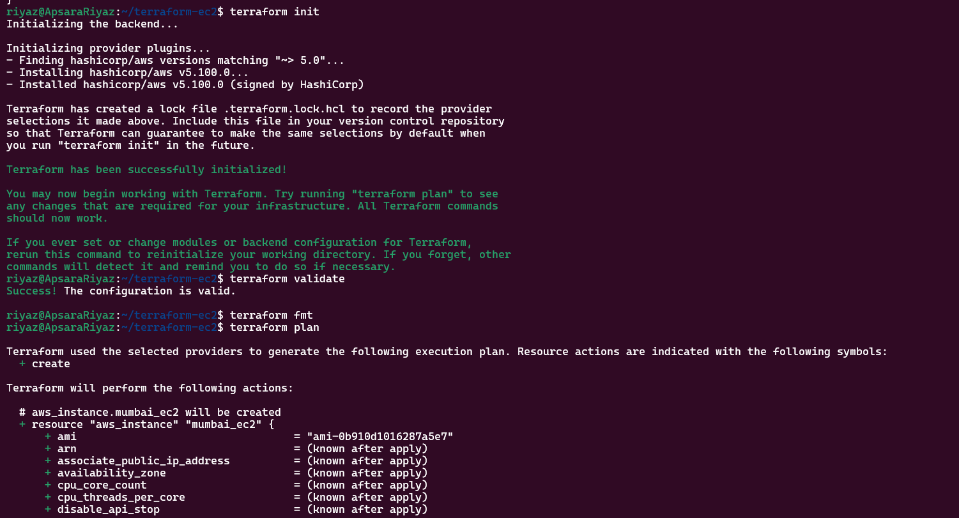

Mumbai-EC2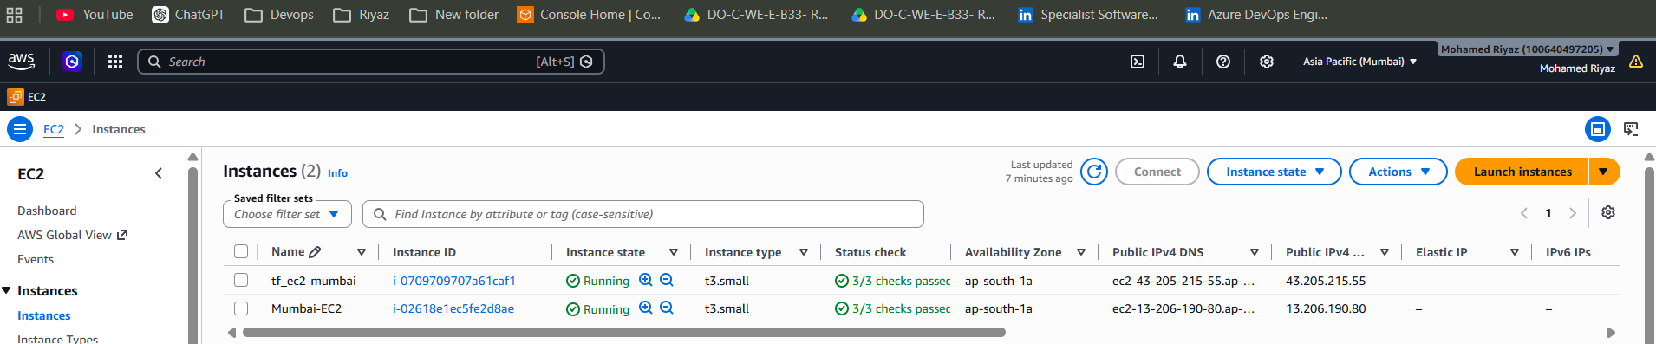

Virginia-EC2
